Week04 – SQL - QUESTIONS

These questions and queries cover a wide range of scenarios commonly encountered in a MKTIME database, utilising joins, subqueries, and aggregate functions to extract meaningful output from the database.

1. List all products.

|  |  |  |
| --- | --- | --- |
| Code | Expected Answer | Actual Answer |
| SELECT * FROM view_items | How many records you expect to display: 10 | 10 rows |
|  |  |  |
|  |  |  |

2. Find the total sales amount for each product.

SELECT item_id, *SUM*(total) AS total_sales  
FROM view_orders  
GROUP BY item_id;

3. List all users who made purchase on 3rd May 2023.

SELECT user_id, order_date  
FROM view_orders  
WHERE order_date = '2023-05-03';

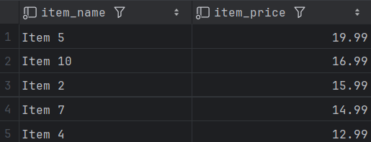4. Find the top 5 costing items.

SELECT item_name, item_price  
FROM view_items  
ORDER BY item_price DESC  
LIMIT 5

5. List all items and who purchased those items.

SELECT u.firstname, o.item_id  
FROM view_orders o, view_users u  
WHERE o.user_id = u.user_id  
ORDER BY o.item_id ASC

6. Find the total order value for each user.

SELECT user_id, *SUM*(payment_amount) AS order_value  
FROM view_payment  
GROUP BY user_id;

7. List all products with their corresponding orders.

SELECT i.item_name, o.total, o.order_date, o.quantity  
FROM view_orders o, view_items i  
WHERE i.item_id = o.item_id  
ORDER BY i.item_name;

8. Find the customer who spent the most in total.

SELECT u.firstname, u.lastname, *SUM*(payment_amount) as total_spend  
FROM view_payment p, view_users u  
WHERE u.user_id = p.user_id  
GROUP BY p.user_id  
ORDER BY total_spend DESC  
LIMIT 1

9. Find the top 3 categories with the highest total sales.

?? No categories given

11. List all orders made by a specific customer (e.g., John Doe).

SELECT *  
FROM view_orders  
WHERE user_id = 1

12. Find the number of orders placed by user_id = 2.

SELECT *  
FROM view_orders  
WHERE user_id = 2

13. List all items with their respective quantities sold.

SELECT item_id, *SUM*(quantity) as Total_Sold  
FROM view_orders  
GROUP BY item_id

14. Find the total sales made by each user.

SELECT u.firstname, u.lastname, *SUM*(payment_amount) as total_spend  
FROM view_payment p, view_users u  
WHERE u.user_id = p.user_id  
GROUP BY p.user_id  
ORDER BY total_spend DESC